Pipestone, Minnesota
September 16, 2024

Pursuant to due call and notice thereof, a regular meeting of the Pipestone City Council was duly held in-person and via Zoom in the Municipal Building at 6:30 p.m. on the 16th day of September 2024. Mayor Dan Delaney called the meeting to order. Roll call was taken and a quorum was declared. Members present: Dan Delaney, Danielle Thompson, Rodger Smidt, Scott Swanson, and Verdeen Colbeck. Absent: None. Others present: Kyle Kuphal, Rebecca Kurtz Financial Advisor for Ehlers, City Engineer Travis Winter via Zoom, City Attorney Jason Hill via Zoom, Cable Access Coordinator Steve Moffitt, Assistant City Administrator/City Clerk Stephanie LaBrune, and City Administrator Deb Nelson.

PLEDGE OF ALLEGIANCE
The Pledge of Allegiance was recited.

APPROVE AGENDA - ADDITIONS, CHANGE OR DELETIONS
Motion was made by Swanson, seconded by Smidt and unanimously carried to approve the agenda with the addition of item I. Schedule Special Meeting on September 19th to discuss the 2025 Budget and Preliminary Levy under New Business.

CONSENT AGENDA
Mayor Delaney stated the Consent Agenda contains the September 3, 2024 Regular Meeting Minutes, September 11, 2024 Special Meeting Minutes, August Financial Reports, and Payment of Claims-Listing of Bills. He then asked if there was any discussion regarding these items. No discussion was held.

Motion was made by Colbeck, seconded by Smidt and unanimously carried to approve the Consent Agenda which consisted of the September 3, 2024 Regular Meeting Minutes, September 11, 2024 Special Meeting Minutes, August Financial Reports, and Payment of Claims-Listing of Bills in the amount of $1,629,142.26 for warrants #073057 to #073161 to be issued in payment thereof.

COMMUNITY CONCERNS – Administrator Nelson stated that there was no one signed in for community concerns and she did not receive any calls or e-mails with concerns.

PRESENTATION
Mayor Delaney welcomed Rebecca Kurtz, financial advisor for Ehlers to the podium to give a presentation on the findings to the city’s sanitary sewer rate study. Kurtz then gave a PowerPoint presentation.

NEW BUSINESS

Consider Approval of JBS Sewer Fees
Delaney stated that the information pertaining to JBS’ sewer fees was provided by Rebecca Kurtz through her Utility Rate Study presentation and shared that the Utility Commission members have been discussing this topic for the past several months. Delaney said the Council can choose the rip the band aid off approach and start charging JBS for their full sewage usage as recommended by Ehlers or accept JBS’ tier rate proposal which would mean modifying the Significant Industrial User (SIU) agreement to include a flat rate increase of $2,500 per month in 2025 and $5,000 per month in 2026. Then in 2027 JBS would begin paying for the SIU agreement plus their full sewer usage rates. Smidt stated that JBS is good for the community and he would like to work with them on this. Swanson stated that he did not think it was entirely JBS’ fault that they were not paying for their full share and stated that he would like to work with them as well. Following discussion, Delaney called for a motion.

Motion was made by Smidt, seconded by Swanson and unanimously carried to approve moving forward with accepting JBS’ tier rate proposal by charging them an additional $2,500 per month in 2025 on top of their current SIU fees and an additional $5,000 per month in 2026 on top of their SIU fees, then in 2027 charging them fully for their SIU agreement and their Sanitary Sewer usage fees.

Request for Council Action
Delaney shared a request for council action from the Pipestone Area Elementary Boosters who is requesting the use Westview Park along with the use of the concession stand and bathrooms, 10 extra picnic tables and four extra garbage totes in addition to what is already there for their annual Back to School Bash on Wednesday, September 25th. Since they are a 501(c)3 nonprofit organization, they are asking the council to please consider waiver of all rental fees so they can continue to expand on this annual event and give the elementary students and their families a fun experience.

Motion was made by Swanson, seconded by Thompson and unanimously carried to approve the Pipestone Area Elementary Booster’s request for council action as presented.

Request for Council Action
Delaney shared a request for council action from the Pipestone Area Chamber of Commerce who is requesting the following for their 10th annual Trunk or Treat & Downtown Candy Walk on Thursday, October 31, 2024. He said they are requesting permission to close the 100 and 200 blocks of West Main St and the 100 block of East Main St from 3:00 p.m. to 6:30 p.m. In addition to Public Works Assistance placing street closed signs, barricades and a few trash cans at the following locations:
- On West Main St by Liberty Pawn (but not blocking 3rd Ave SW/NW)
- On East Main St by First Farmers & Merchants Bank (but not blocking 3rd Ave SE/NE)
- On the intersections of 2nd Avenue SW/NW and Hiawatha Avenue N/S
Delaney said the Trunk or Treat event has been approved in the past.

Motion was made by Thompson, seconded by Colbeck and unanimously carried to approve the Pipestone Area Chamber of Commerce’s request for council action as presented.

Overhead Airport Hangar Door
Delaney said during an Airport Commission meeting, it became known that the overhead door on the blue hangar is in need of replacement. Airport Manager, Rob Dykstra has acquired a quote from Powerlift Hydraulic Doors for $32,958 and is proposing to replace the hydraulic door due to safety concerns.

Motion was made by Smidt, seconded by Swanson and unanimously carried to approve the quote from Powerlift Hydraulic Doors to install a new airport hangar door in the amount of $32,958.

Discuss Renaming a Segment of 2nd Ave NE
Delaney shared with the council that he would like to rename the segment of road on the west side of the city’s water treatment plant to Totman Drive to honor the Totman brothers who served in the military and also Harold Totman who assisted the Sheriff’s department for many years and volunteered in several ways throughout the city. Discussion was held on how the road became 2nd Ave and if the road had ever officially been named or not. Following discussion, Delaney directed staff to research the subject to see if it could be named Totman Drive.

*Councilmember Colbeck removed himself from the meeting.

Resolution 2024-51
Delaney stated Resolution 2024-51 is a Resolution Granting a Variance to install a second sign that exceeds the required size limitations at the Meinders Library building at 220 3rd Ave. S.E. He said a public hearing was held on August 20th by the Board of Appeals and Adjustments and they are recommending that the Council approves Resolution 2024-51 to grant the variance request.

Motion was made by Swanson, seconded by Smidt and unanimously carried, 4-0, to approve resolution 2024-51: A Resolution Granting a Variance to install a second sign that exceeds the required size limitations at 220 3rd Avenue SE in the City of Pipestone.

Resolution 2024-52
Delaney stated Resolution 2024-52 is a Resolution Denying a Variance to construct a garage in excess of allowed square footage at 307 6th St. S.W. He said a public hearing was held on August 27th by the Board of Appeals and Adjustments and they are recommending that the Council approves Resolution 2024-52 to Deny the variance request. Delaney explained that denying the variance would not stop the applicant from building a building that meets city code.

Motion was made by Smidt, seconded by Thompson and unanimously carried, 4-0, to approve resolution 2024-52: A Resolution Denying a Variance to construct a garage in excess of allowed square footage at 307 6th Street SW in the City of Pipestone.

Resolution 2024-53
Delaney stated Resolution 2024-53 is a Resolution Granting a Variance to construct a truck wash and additional farm buildings within a 300-foot setback on property located near the intersection of 121st St. and County Road 67. He said a public hearing was held on August 20th by the Board of Appeals and Adjustments and they are recommending that the Council approves Resolution 2024-53 to grant the variance request. Delaney then shared that a letter was received following the public hearing from Lauren Blacik, the superintendent of the Pipestone National Monument and said that Lauren would like the letter read into the meeting record. Smidt stated that since there was notice of the public hearing and that the public hearing had already been done, he does not think the letter should be read at this time.

Following a motion made by Swanson and seconded by Smidt, Mayor Delaney read the following letter into the record:

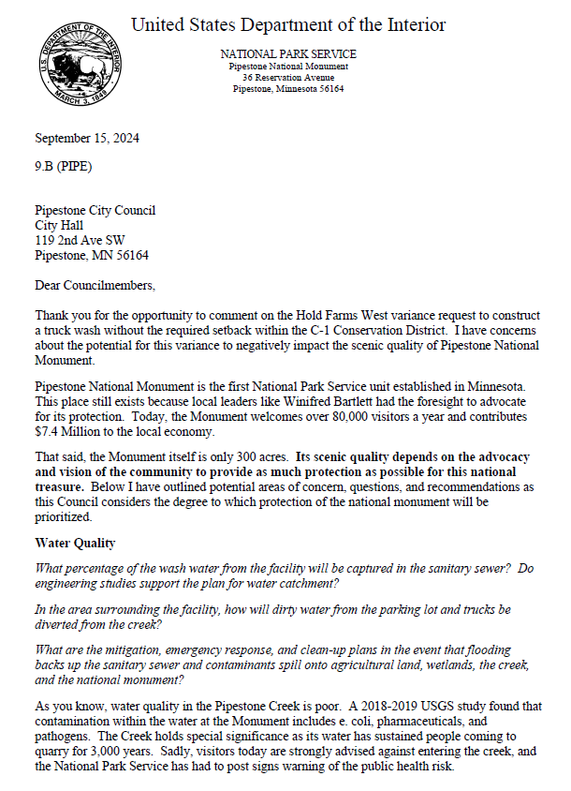

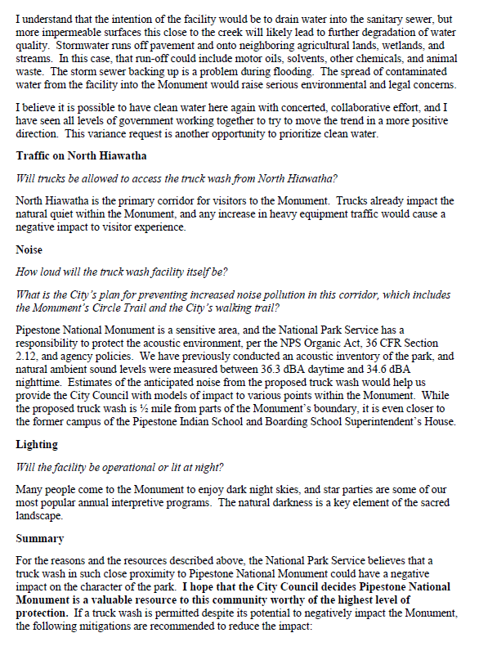

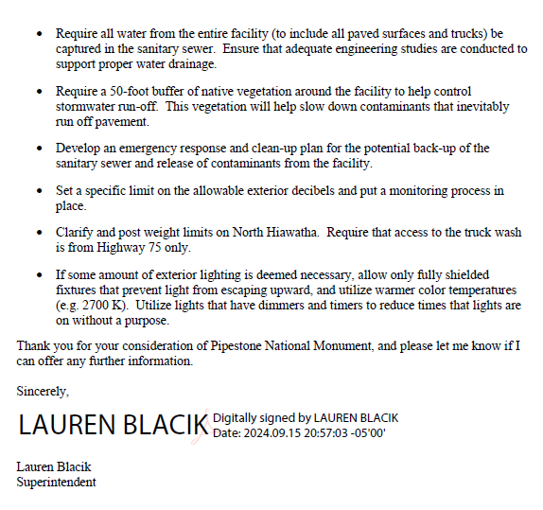
Motion unanimously carried, 4-0, to approve resolution 2024-53: A Resolution Granting a Variance to construct a truck wash and additional farm buildings within a 300-foot setback on property located near the intersection of 121st St. and County Road 67 in the City of Pipestone.

Schedule Special Budget Meeting
Delaney called for a motion to schedule a special meeting to discuss the 2025 budget and approve the city’s preliminary levy on September 19, 2024 at 5:30 p.m. in the council chambers at City Hall.

Motion was made by Smidt, seconded by Swanson and unanimously carried, 4-0, to schedule a special meeting to discuss the 2025 budget and approve the city’s preliminary levy on September 19, 2024 at 5:30 p.m. in the council chambers at City Hall.

CLOSING COMMENTS
Administrator Nelson – announced City-wide cleanup drop off event dates, October 7th – October 11th and the final mowing of the cemeteries will be October 4th as the city plans to spray on October 7th. Mayor Delaney also stated that if anyone has artificial flowers that are looking nice, they will stay and removed if they are in poor condition.
ADJOURNMENT
Motion made by Thompson, seconded by Smidt and unanimously carried to adjourn the meeting at 7:38p.m.

Dan Delaney
Mayor

ATTEST:

Stephanie LaBrune
Assistant City Administrator / City Clerk

